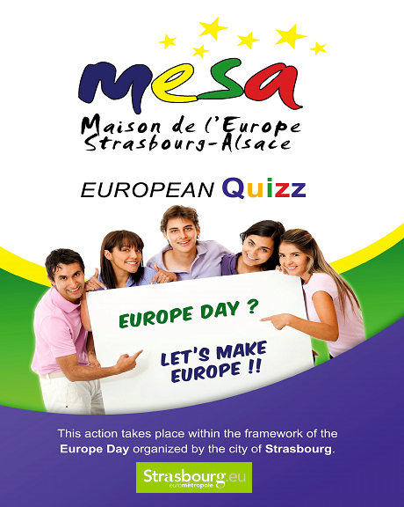
20. What is the European emergency number?
- A 911
- B 110
- C 112
21. What is European Voluntary Service?

- A a program which replaces the military service
- B a program that gives the opportunity to participate at a project of general interest in another European country
- C a program that helps young people to work in another European country
22. Why are there 12 stars on the European flag?
- A it is a symbol of perfection and abundance
- B it is the number of founding states of the EU
- C there had to be 12 stars to form a circle

23. What is the European citizen consultation process?
- A a referendum on exit from Europe such as Brexit
- B another term for European elections
- C meetings to collect European citizens’ views in order to include them in an EU radical reform process

24. When will the next European elections take place?
- A From January, 23rd to 26th 2019
- B From May, 23rd to 26th 2019
- C From December, 23rd to 26th 2019

25. With which of these cities is Strasbourg not twinned?
- A Boston (USA)
- B Dresden (Germany)
- C Leicester (UK)
- D Ramat-Gan (Israel)
- E Seville (Spain)
- F Stuttgart (Germany)
Last Name: __________________________________________ First Name: _______________________________________________________

Date of birth: ________ / ________ / ___________________ Nationality: _______________________________________________________

E-mail: ________________________________________________ Phone: _____________________________________________________________

Address: ____________________________________________________________________________________________________________________
To send before 15 June 2018: by letter to MESA - 9, Place Kléber, 67000 Strasbourg (France)
or by mail to secretariat.mesa@gmail.com (see also our Web site : www.mesa-strasbourg.eu)
Edition 2018

http://FACEBOOK/MESA – MAISON DE L’EUROPE STRASBOURG ALSACE

This quiz addresses the young people from 15 to 25 years old. Some prices will be drawn lots among the BEST ANSWERS!
Only one answer is possible by question

1. Which State is not part of the European Union?
- A Finland
- B Poland
- C Switzerland
2. Which State was not a founding member of the European Union?
- A Germany
- B Italy
- C the United Kingdom
3. Which State became the 28th member of the European Union in 2013?
- A Croatia
- B Estonia
- C Serbia
4. Which country organized a referendum on leaving the European Union in 2016?
- A Sweden
- B the United Kingdom
- C Greece
5. Which agreement allows European citizens to move freely in most European countries?
- A Schengen
- B Maastricht
- C Lublin
6. What is the name of the program which allows European students to do part of their studies in another European country?
- A Leader
- B Erasmus+
- C Horizon 2020
7. Where was the last EU treaty signed?
- A Brussels
- B Lisbon
- C Amsterdam
8. What is the name of the President of the European Commission?
- A Pierre Moscovici (France)
- B Jean-Claude Juncker (Luxembourg)
- C Martin Schultz (Germany)
9. What is the name of the President of the European Parliament?
- A Antonio Tajani (Italy)
- B Daniel Cohn-Bendit (France/Germany)
- C Carles Puigdemont (Spain)

10. Which European policy has the biggest budget?
- A the Common Agriculture Policy
- B the Common Foreign and Security Policy
- C the European Immigration and Asylum Policy
11. How often do the European elections take place?
- A Every 2 years
- B Every 5 years
- C Every 8 years
12. Which is the minimum age to be able to vote and stand for election to the European parliament in most member-States?
- A 18 years old
- B 21 years old
- C 25 years old
13. Which institution is not part of the European Union?
- A the European Commission
- B the Council of Europe
- C the European Council
14. Which is the judicial body of the European Union?
- A the European Court of Human Rights
- B the Court of Justice of the European Union
- C the Council of the European Union
15. How many States are members of the Council of Europe in 2018?
- A 47
- B 27
- C 28
16. Where is the European Court of Human Rights located?
- A Strasbourg
- B Luxembourg
- C Brussels
17. Which Head of State or Government has recently taken initiatives to revive Europe?
- A Theresa May (UK)
- B Viktor Orbán (Hungary)
- C Emmanuel Macron (France)
18. Which one of these institutions is located in Strasbourg?
- A the European Commission
- B the Council of Europe
- C The Council of the European Union
19. Is it possible to attend plenary sittings of the European Parliament in Strasbourg?
- A Yes
- B No

